Python Lab

1. In Databricks go to Workspace, Users, Your User, select ellipses, and Import

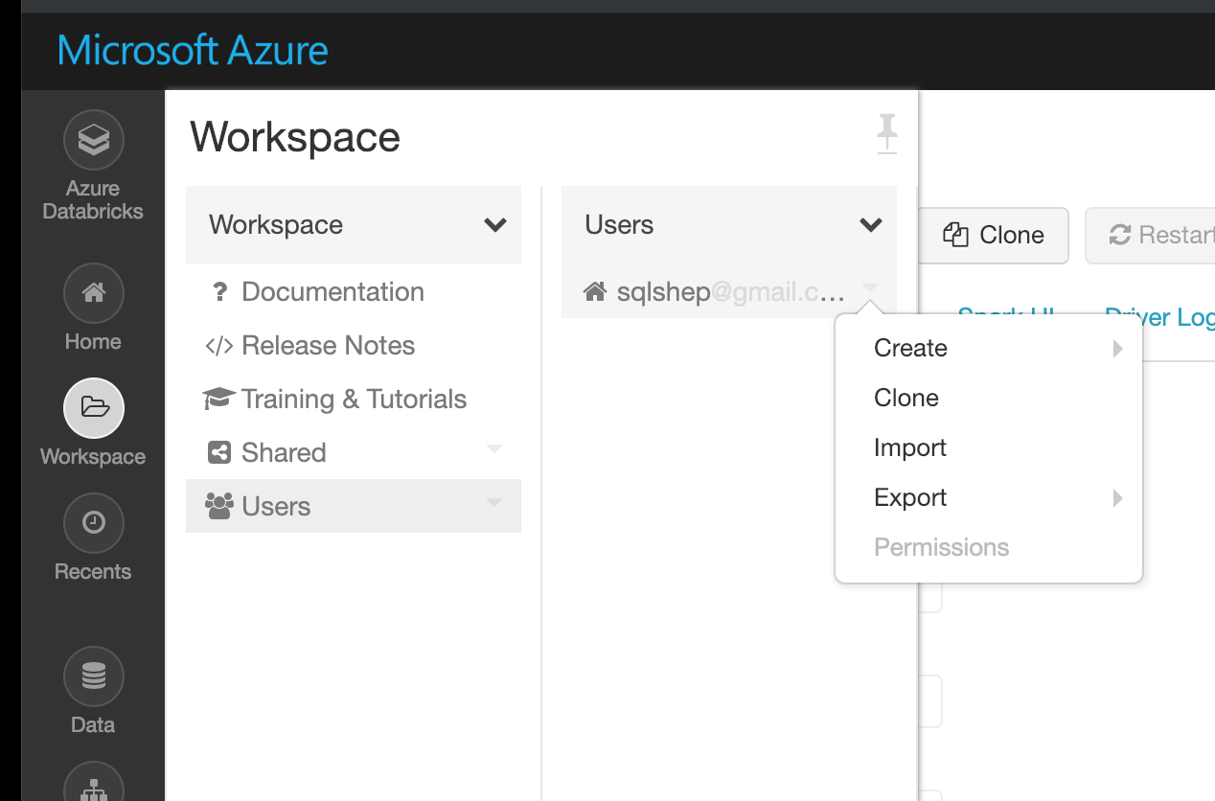

1. Paste the following link for the first Python notebook.

https://raw.githubusercontent.com/sqlshep/SQLShepBlog/master/Labs/Lab%20Python%20Pt%201.ipynb

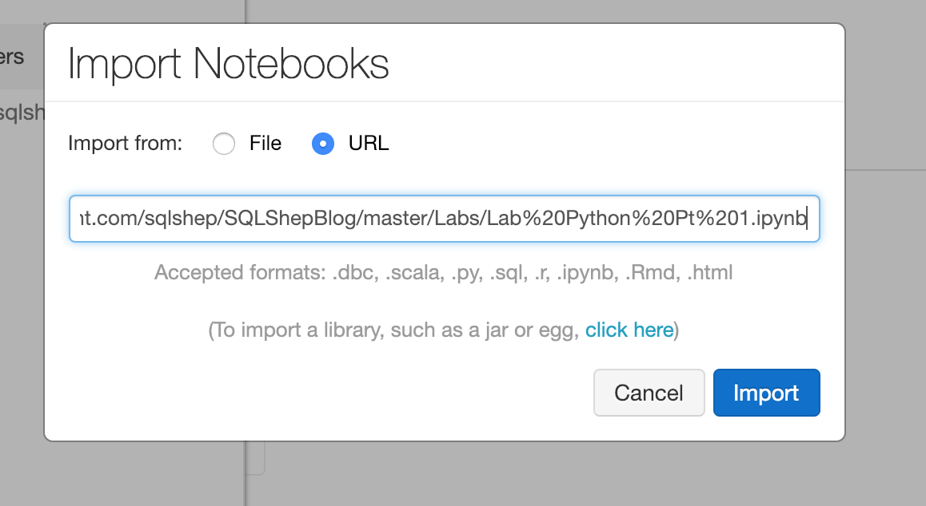

1. Follow the same instructions above for the second python Notebook

https://raw.githubusercontent.com/sqlshep/SQLShepBlog/master/Labs/Lab%20Python%20Pt%202.ipynb